Captcha generator

The Captcha Generator is a utility for generating captcha images with customizable configurations. Captchas are commonly used to prevent automated bots from accessing or submitting data on web forms

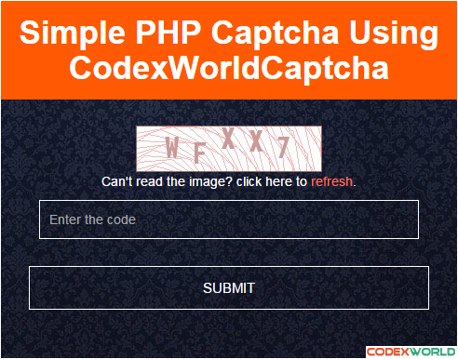

-By

Navya Charitha

M. Maha Lakshmi

Mahalakshmi. K

Daffny Sharon

Induja

# import java.util*

The use of keyword ‘import’ in Java programming is used to import the built-in and user-defined packages, class or interface in Java Programming

Util package in Java is built-in package that contains several pre-written utility classes and interfaces. The import java.util; statement can be used to load the contents of the java.util package in a Java program.

## Import java.util.Random

The java.util.Random class is used to generate pseudorandom numbers. The methods implemented by this class are used to generate different random data types such as int , double , and float.

In this program we used this class to generate random numbers.

# Public class:

Public is a java keyword which declares members access as public, while a class has “default” or “package” visibility i.e. the class is accessible only to the classes inside the same package.

## Public class Captcha Generator

A class named “Captcha Generator” is defined. This class contains a method to generate a CAPTCHA text.

Captcha Generator class: A class named captcha generator is defined. This class contain a method to generate the CAPTCHA text**.**

# Generate Captcha Method: **This method takes an integer argument length that specifies the desired length of the CAPTCHA text string.**

# String :

A string is a sequence of characters that exists as an Object of the class. Java Strings are created and manipulated through the string class. A string is a immutable i.e. its value cannot be changed. This string contains the set of characters that can be used in CAPTCHA.

# String Builder:

# mutable, or in other words, a modifiable succession of characters.

A StringBuilder object named captcha is created. This object is used efficiently build the CAPTCHA text string.

# Random

The methods implemented by this class are used to generate different random data types such as int, double, and float.

# Random character selection:

A loop iterates length number of times. In each iteration, a random index is generated using nextInt(characters. length()). This index is used to select a random characters from the characters string.

The selected character is appended to the captcha object using the append method.

# Append: It is an inbuilt method in java which is used to append the string representation of the Boolean argument to a given sequence.

# For loop:

**Java for loop provides a concise way of writing the loop structure. The for statement consumes the initialization, condition and increment/decrement in one line thereby providing a, easy-to-debug structure of looping.**

# **Return:**

In java, return is a reserved keyword i.e., we can’t use it as an identifier. It is used to exit from a method, with or without value.

# Return CAPTCHA:

After the loop completes, the toString method is called on the captcha object to convert it into a regular string .

This string is returned from the generateCaptcha method.

# Public static void main():

main() is public static void for accessibility and to serve as the program’s entry point without returning value.

Public ensures that the method is accessible from outside the class. Static method belongs to the class, not a instance of the class.

Void indicates that the main() method doesn’t return any value

# Main method:

The main method demonstrates how to use the generate Captcha method.

It sets the desired CAPTCHA length (e.g., 6 characters) in the captcha Length variable.

It calls the generateCaptcha method with the CaptchaLength argument and stores the generated CAPTCHA text in the captcha variable.

# System. out. Println ():

It is a method in Java that prints a message to the standard output (typically the console) and appends a newline character. It’s widely used to display messages, data, and the results of operations during the execution of a program.

System. Out. Println (captcha), finally it prints the CAPTCHA text to the console using system. Out. Println.

# Code for captcha generation:

import java.util.Random;

public class CaptchaGenerator {

public static String generateCaptcha(int length) {

String characters = "abcdefghijklmnopqrstuvwxyzABCDEFGHIJKLMNOPQRSTUVWXYZ0123456789";

StringBuilder captcha = new StringBuilder();

Random random = new Random();

for (int i = 0; i < length; i++) {

int index = random.nextInt(characters.length());

captcha.append(characters.charAt(index));

}

return captcha.toString();

}

public static void main(String[] args) {

int captchaLength = 6;

String captcha = generateCaptcha(captchaLength);

System.out.println("CAPTCHA: " + captcha);

}

}

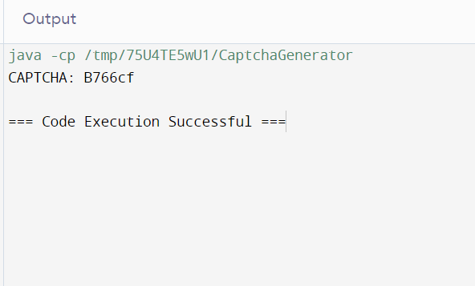

This code provides a basic example of CAPTCHA generation in java.

THANK YOU